User Manual
  - INVENTORY MODULE

  - 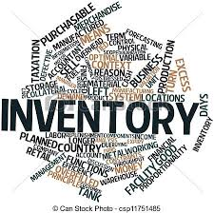

  - All Rights Reserved: Megaplus Technologies
Table of Contents
Starting work on ERP: 3
➢ Login Screen: 3
Login : 3
➢ Add Item: 4
➢ Add New Company: 7
➢ Purchase Order: 8
➢ Approve Purchase Order: 9
➢ Purchase Order Expense: 10
➢ Search Purchase Order: 10
➢ Receive Inventory By PO: 11
➢ Item Wise Stock: 12
➢ Item Wise Stock/Consumption: 13
➢ Stock in Transit: 14
➢ Stock In/Out Report: 15
➢ Min Approval Authorities: 15
➢ Approval Authorities: 16
➢ Internal Requisitions: 16
➢ Search Requisitions: 17
➢ My Pending Approvals: 18
➢ Approved Requisition: 19
➢ Delivery Challan: 19
➢ Create Quotation: 20
➢ Receive Inventory By Request: 21
➢ Party Ledger: 22
➢ Party Payable and Receivable: 22
➢ Min Approval Authority For Demand Requisition: 23
➢ Approval Authorities For Demand Requisition: 24
➢ Demand Requisition: 24
➢ Search Demand Requisitions: 25
➢ My Pending Approvals Requests: 26

Starting work on ERP:
- Open Chrome, Firefox, Safari or Internet Explorer.
- Enter url in URL Bar:
http://192.168.8.94/demo/login.aspx

Login Screen:

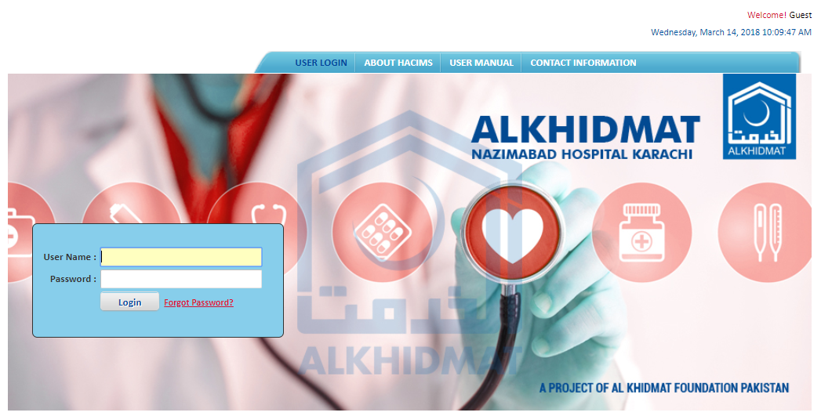

Login :
- Enter login details and click on Login.
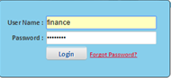

Add Item:
- Click on Inventory Module from menu bar.
- Select Add Item from drop down list of inventory module.
- Screen will appear as mention below screen.
- To search Existing Items click on search.
- To search Existing Single Item enter item name in item text box.
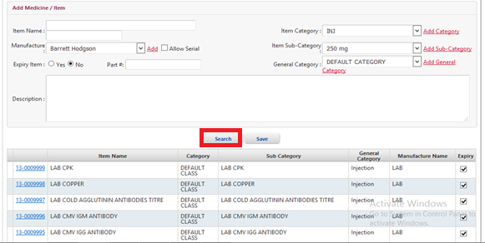
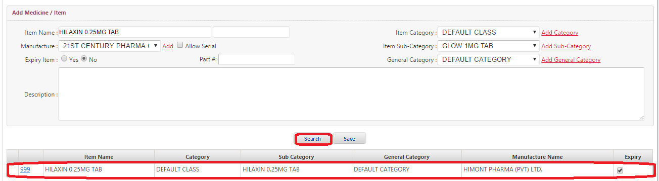

To add new item enter the details in text boxes.
- Enter Item Name in Item Name text box.
- Enter the Manufacturer by click on Add
- Screen will mention as mention below to add manufacturer.
- Enter the Manufacturer Name from this list given below of screen.
- Then click on save.
- After selecting Manufacturer click on Allow Serial check box.
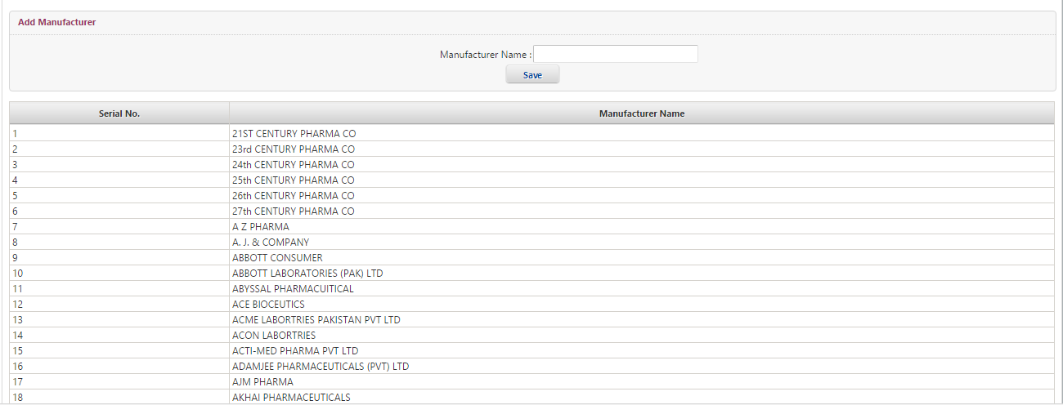

- Select Expiry Item by click on Yes or No radio button.
- Enter Part# in part# text box.
- Select Item Category by click on Add Category.
- Screen will appear as mention below.
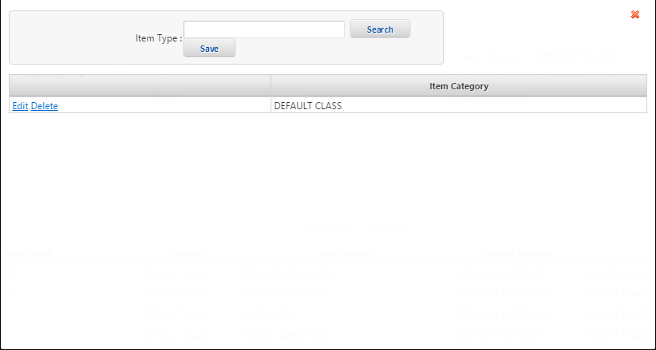

- Select Item Sub-Category by click on Add Sub-Category.
- Screen will appear as mention below.
- Enter Item Name.
- To Delete or Edit Item click on Edit/Delete.
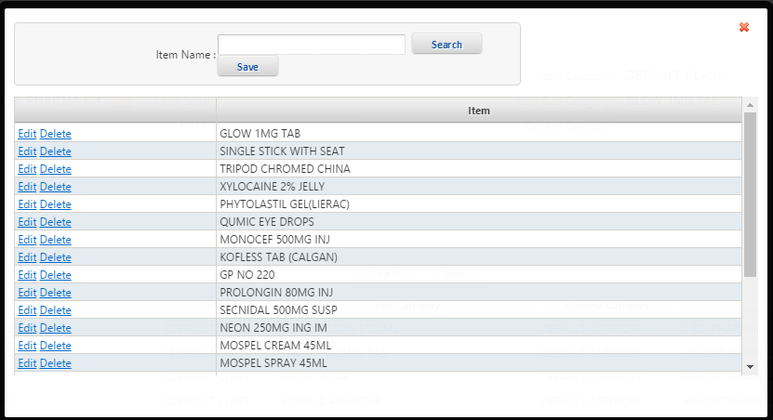

- Select General Category by click on Add General Category which is by default.
- Screen will appear as mention below.
- Enter Category Name and Category Abbreviation.
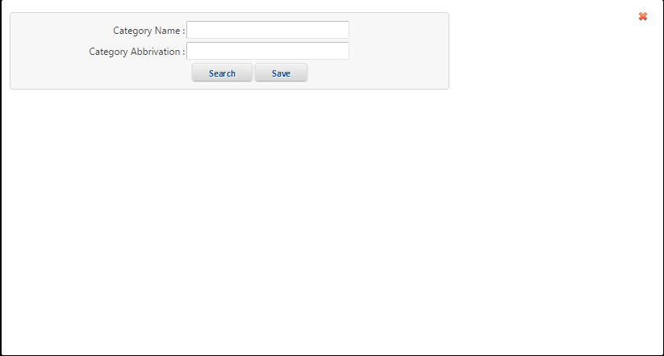
- Enter Description in Description text box.
- Click on Save.
- New Item will added and show at the bottom of screen.

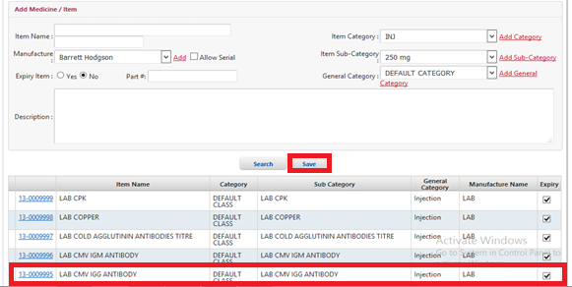

Add New Company:
- Click on Inventory Module from menu bar.
- Select Add New Company from drop down list of Inventory Module.
- Screen will appear as mention below screen.
- Select Company Type by click on radio button from the list.
- Enter Company/Party Name in Company/Party Name text box.
- Search NTN# in NTN# search box.
- Enter City in City text box.
- Enter Address in Address text box.
- Enter Contact Person Name in Contact Person Name text box.
- Enter CNIC in CNIC text box.
- Enter Phone in Phone text box.
- Enter Fax in Fax text box.
- Enter Email in Email text box.
- Enter Website in Website text box.
- Enter STR# in STR# text box.
- Enter Bank A/C No. in Bank A/C No. text box.
- Select Status from drop down list of select box.
- Click on save button.
- Information will save successfully and show at the right side of screen.
- To see and update the information of existing company click on Select form list of Companies.

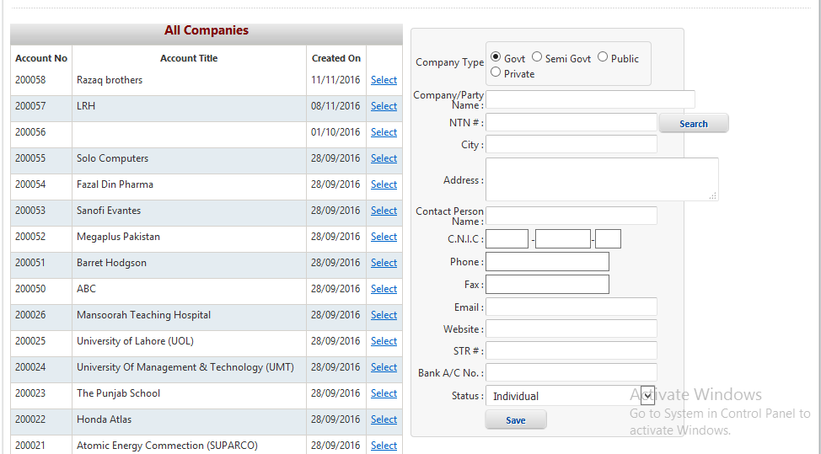

Purchase Order:
- Click on Inventory Module from menu bar.
- Select Purchase Order from drop down list of Inventory Module.
- Screen will appear as mention below screen.
- Enter Purchase Order# in Purchase Order# text box.
- Select P.O Date from drop down P.O Date dialog box.
- Enter Payment To in Enter Payment text box.
- Enter Order To in Enter Order text box.
- Select Other Currency from drop down list of Other Currency select box.
- Enter Currency Rate in Currency Rate text box.
- Select PO Type from drop down PO Type dialog box.
- Select Mode of Payment from drop down list of Mode of Payment select box.
- Enter detain of For Branches in For Branches text box.
- Enter detain of Mode Of Delivery in Mode of Delivery text box.
- Enter detain of Ship to in Ship to text box.
- Enter Term and Conditions in Term and Conditions Text box.
- Enter Payment Process in Payment Process text box.
- Enter Item Name in Item Name text box.
- Add Demand# by click on Add of demand# text box.
- Click on Search button.
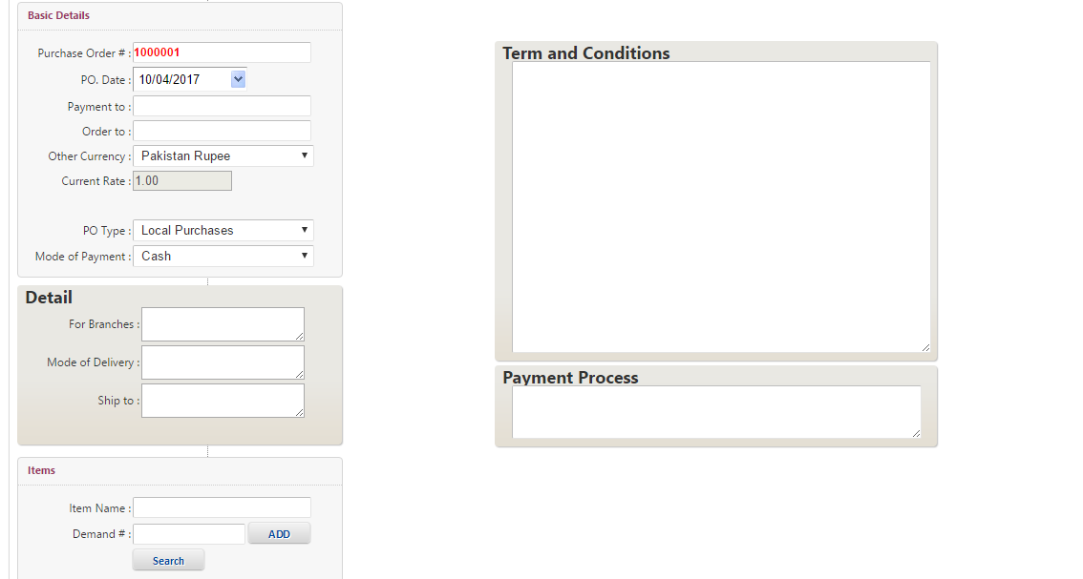

Approve Purchase Order:
- Click on Inventory Module from menu bar.
- Select Approve Purchase Order from drop down list of Inventory Module.
- Screen will appear as mention below screen.
- See the Purchase Order Status.
- To Approve the Purchase Order click on Approve PO.
- To Reject Purchase Order Click on Reject PO.

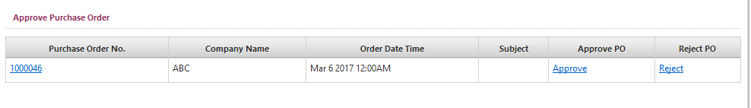

Purchase Order Expense:
- Click on Inventory Module from menu bar.
- Select Purchase Order Expense from drop down list of Inventory Module.
- Screen will appear as mention below screen.
- Enter Purchase Order # in Purchase Order # text box.
- Select Purchase Order # from drop down list of Purchase Order # select box.
- Select P.O Date from drop down list of P.O Date Dialog box.
- Select Company from drop down list of Company select box.
- Enter Term and Conditions in Term and Conditions text box.
- Then click on Report button.

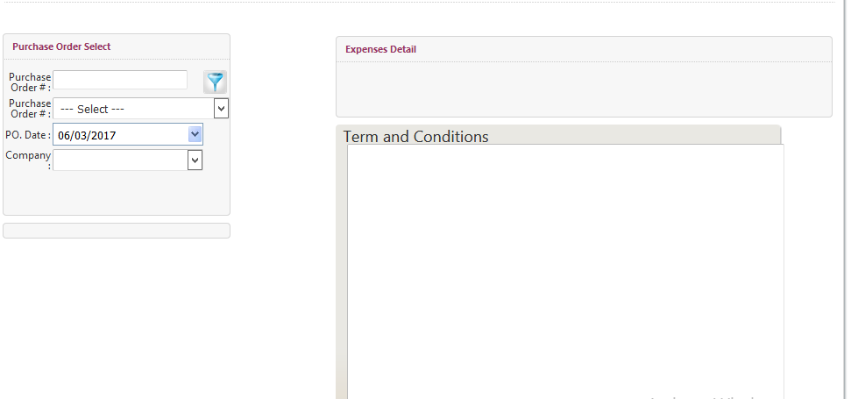

Search Purchase Order:
- Click on Inventory Module from menu bar.
- Select Search Purchase Order from drop down list of Inventory Module.
- Screen will appear as mention below screen.
- Search Purchase Order by different parameters.
- Enter Purchase Order No in Purchase Order No text box.
- Select Date from drop down Date From dialog box.
- Select Payment To from drop down list of Payment To select box.
- Enter Order No in Order No text box.
- Select Office from drop down list of Office From select box.
- Select Date To from drop down Date TO dialog box.
- Enter Item Name in Item Name text box.
- Enter Quotation No in Quotation No text box.
- Click on Search button.
- List of purchase order will display at the bottom of screen.
- To report about Purchase Order click on Report.

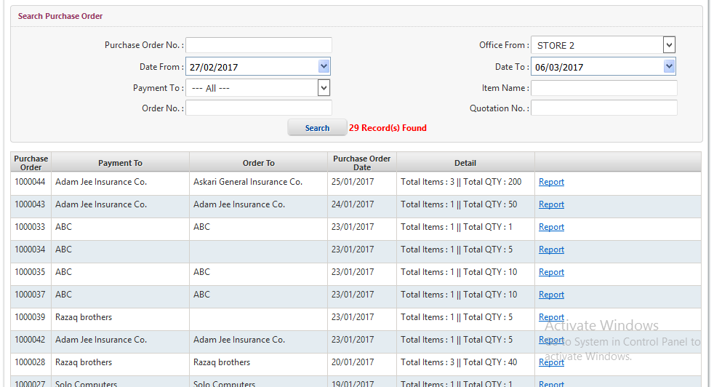

Receive Inventory By PO:
- Click on Inventory Module from menu bar.
- Select Receive Inventory By PO from drop down list of Inventory Module.
- Screen will appear as mention below screen.
- Select Order from drop down list of Order select box.
- Select Receive Date from drop down Receive Date From dialog box.
- Select Receive Date To from drop down list of Receive Date tO select box.
- Select Company from drop down list of Company select box.
- Select Department from drop down list of Department select box.
- Select Sub-Department from drop down list of Sub-Department select box.
- Click on Search button.
- List of Receive Stock will display at the bottom of screen.
- To confirm the receive Inventory By PO click on Receive.
- To view the Item click on View Item.

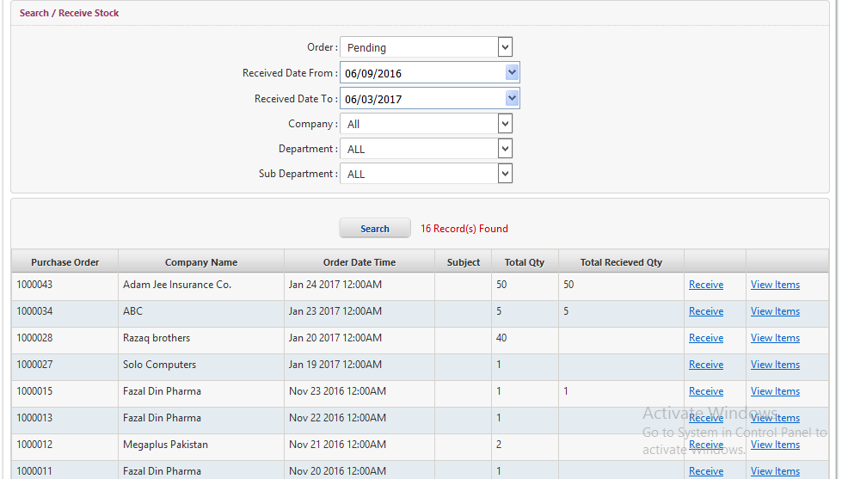

Item Wise Stock:
- Click on Inventory Module from menu bar.
- Select Item Wise Stock from drop down list of Inventory Module.
- Screen will appear as mention below screen.
- Select Manufacturer from drop down list of manufacturer select box.
- Enter Item Name in Item Name text box.
- Enter Part # in Part # text box.
- Enter Order No in Order NO text box.
- Click on View Report button.
- Item Wise Stock Report will display at the bottom of screen.
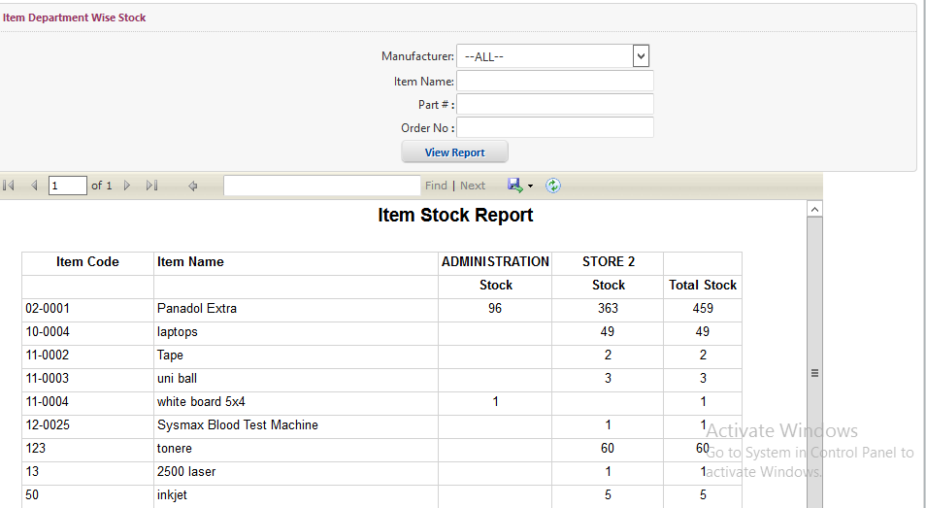

Item Wise Stock/Consumption:
- Click on Inventory Module from menu bar.
- Select Item Wise Stock/Consumption from drop down list of Inventory Module.
- Screen will appear as mention below screen.
- Select Manufacturer from drop down list of manufacturer select box.
- Enter Item Name in Item Name text box.
- Enter Part # in Part # text box.
- Enter Order No in Order NO text box.
- Click on View Report button.
- Item Wise Stock/Consumption Report will display at the bottom of screen.

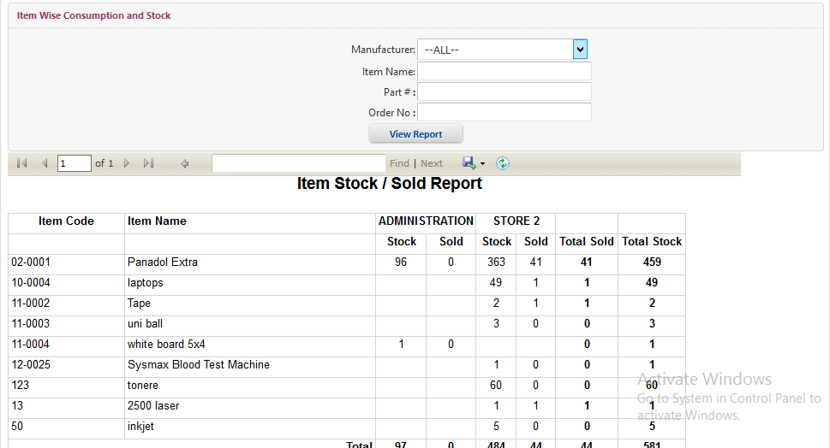

Stock in Transit:
- Click on Inventory Module from menu bar.
- Select Stock in Transit from drop down list of Inventory Module.
- Screen will appear as mention below screen.
- Select Manufacturer from drop down list of manufacturer select box.
- Enter Item Name in Item Name text box.
- Enter Part # in Part # text box.
- Enter Order No in Order NO text box.
- Click on View Report button.
- Stock in Transit Report will display at the bottom of screen.

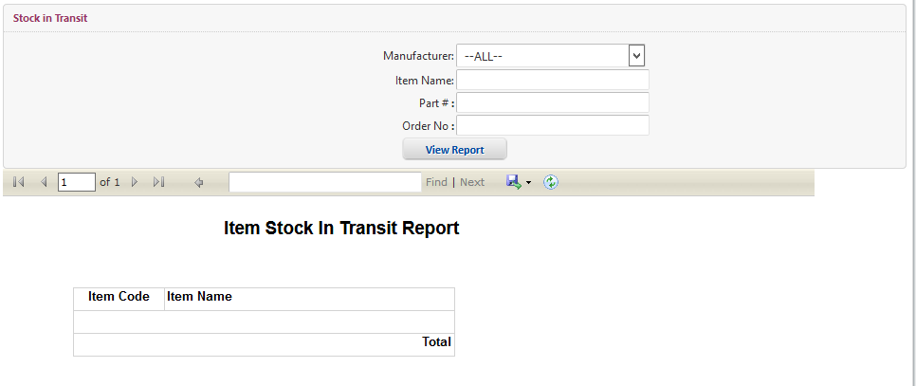

Stock In/Out Report:
- Click on Inventory Module from menu bar.
- Select Stock In/Out Report from drop down list of Inventory Module.
- Screen will appear as mention below screen.
- Select Sub-Department from drop down list of Sub-Department select box.
- Select From Date from drop down Receive from Date dialog box.
- Select To Date from drop down list of Receive To Date select box.
- Click on View Report button.
- Stock In/Out Report will display at the bottom of screen.

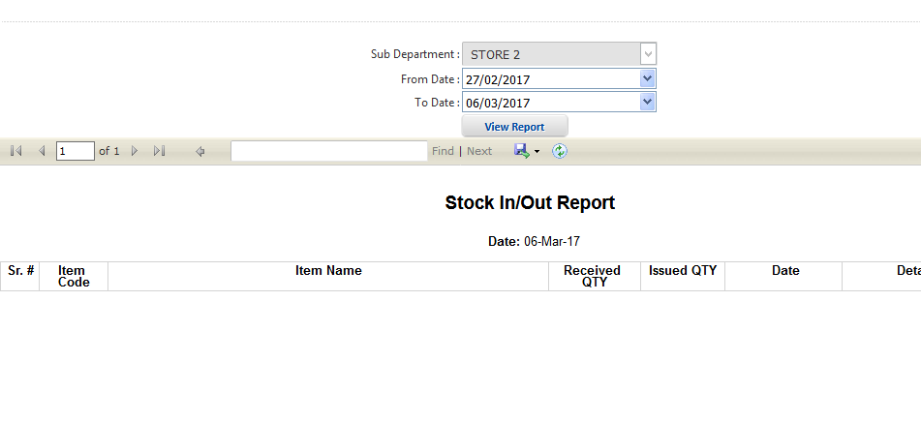

Min Approval Authorities:
- Click on Inventory Module from menu bar.
- Select Min Approval Authorities from drop down list of Inventory Module.
- Screen will appear as mention below screen.
- Select Sub-Department from drop down list of Sub-Department select box.
- Select Level from down list of level select box.
- Click on save button.
- Detail will save and display at the bottom of screen.

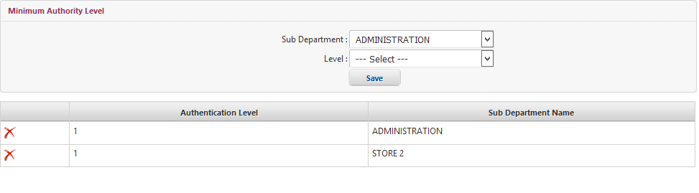

Approval Authorities:
- Click on Inventory Module from menu bar.
- Select Approval Authorities from drop down list of Inventory Module.
- Screen will appear as mention below screen.
- Select Sub-Department from drop down list of Sub-Department select box.
- Select Employee (Authority) from drop down list of Employee (Authority) select box..
- Select Level from down list of level select box.
- Click on save button.
- Approval Authorities Detail will display at the bottom of screen.

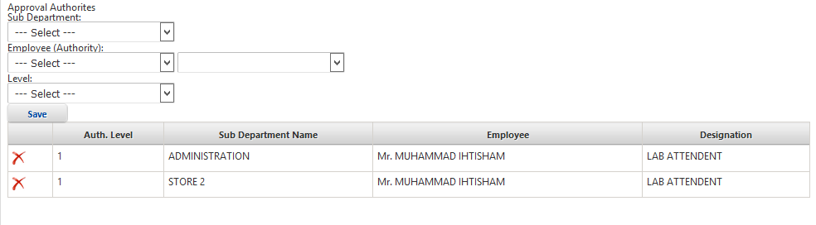

Internal Requisitions:
- Click on Inventory Module from menu bar.
- Select Internal Requisition from drop down list of Inventory Module.
- Screen will appear as mention below screen.
- Enter Official Information.
- Select Office from drop down list of Office select box.
- Select Send TO Office from drop down list of Send To Office select box.
- Select For Store from drop down list of For Store select box.
- Enter Requisition Description in Requisition Description text box.
- Search Item by enter Item Name in Item Name text box.
- Select Manufacturer from down list of manufacturer select box.
- Click on Search button.
- Enter Customer Information.
- Enter Customer Name in text box and Select Company of customer from select box.
- Enter Contact Person in Contact Person text box.
- Enter Contact # in Contact # text box.
- Enter Email in Email text box.
- Enter Delivery Address in Delivery Address text box.
- To roll back click on Roll back button.
- To save information click on Save & Submit button.
- To view report click on Report button Report will appear.

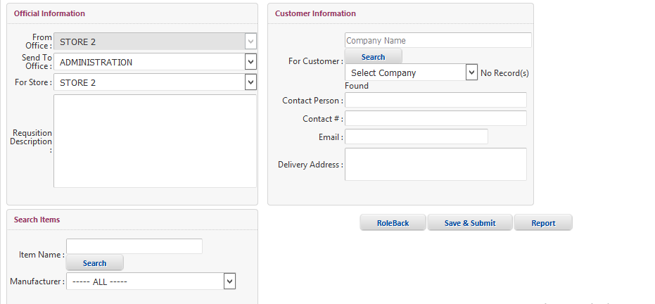

Search Requisitions:
- Click on Inventory Module from menu bar.
- Select Search Requisition from drop down list of Inventory Module.
- Screen will appear as mention below screen.
- Enter Requisition # in requisition text box.
- Select Employee from drop down list of Employee select box.
- Select From Date from drop down From Date dialog box.
- Select Department from down list of department select box.
- Click on Pending work flow check box.
- Select To Date from drop down To Date dialog box.
- Click on View Requisition.
- Requisition detail will show.

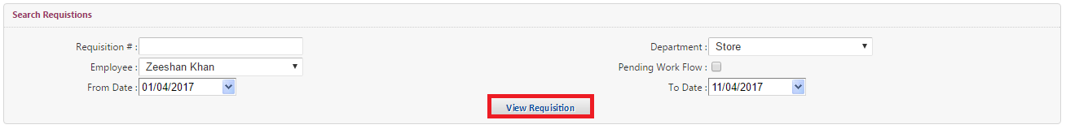

My Pending Approvals:
- Click on Inventory Module from menu bar.
- Select My Pending Approvals from drop down list of Inventory Module.
- Screen will appear as mention below screen.
- For Approval Request click on Approve & Forward.

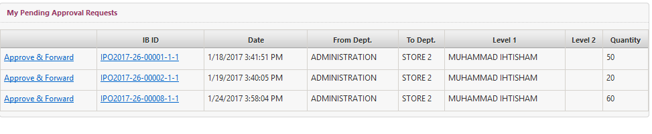

Approved Requisition:
- Click on Inventory Module from menu bar.
- Select Approved Requisition from drop down list of Inventory Module.
- Screen will appear as mention below screen.
- Select Date from drop down Date From dialog box.
- Select Date To from drop down Date To dialog box.
- Enter Requisition NO in requisition no text box.
- Enter Requisition For in requisition for text box.
- Enter for Department in For Department text box.
- Click in Search Button.
- Approval Requisition detail will display at the bottom of screen.

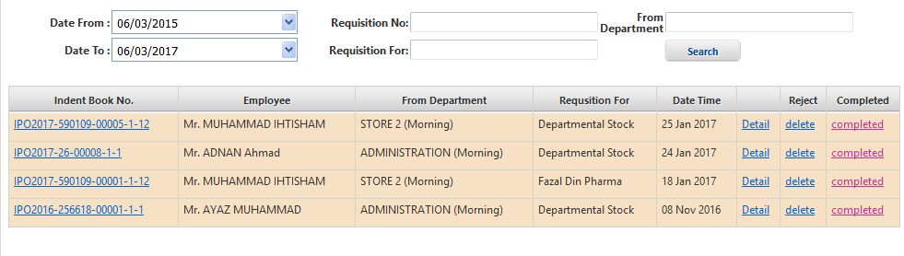

Delivery Challan:
- Click on Inventory Module from menu bar.
- Select Delivery Challan from drop down list of Inventory Module.
- Screen will appear as mention below screen.
- Select Company from drop down list of Company select box.
- Select Branch from drop down list of Branch select box.
- Select Issue Date from drop down Issue Date From dialog box.
- Select Issue Date To from drop down Issue Date To dialog box.
- Enter Requisition no in requisition no text box.
- Enter Customer Name in Customer Name for text box.
- Click in Search Button.
- Delivery Challan detail will display at the bottom of screen.

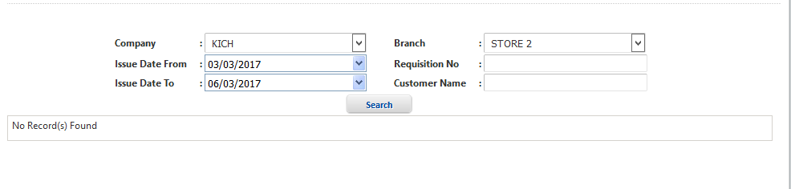

Create Quotation:
- Click on Inventory Module from menu bar.
- Select Create Quotation from drop down list of Inventory Module.
- Screen will appear as mention below screen.
- Enter Requisition No in requisition no text box.
- Enter Department in Department text box.
- Select From Date from drop down From Date dialog box.
- Select To Date from drop down To Date dialog box.
- Click in Search Button.
- Create Quotation detail will display at the bottom of screen.
- To add quotation click on Add Quotation.
- To see quotation report click on View Report.
- To view quotation click on View.
- To see detail Requisition no click on Requisition No.

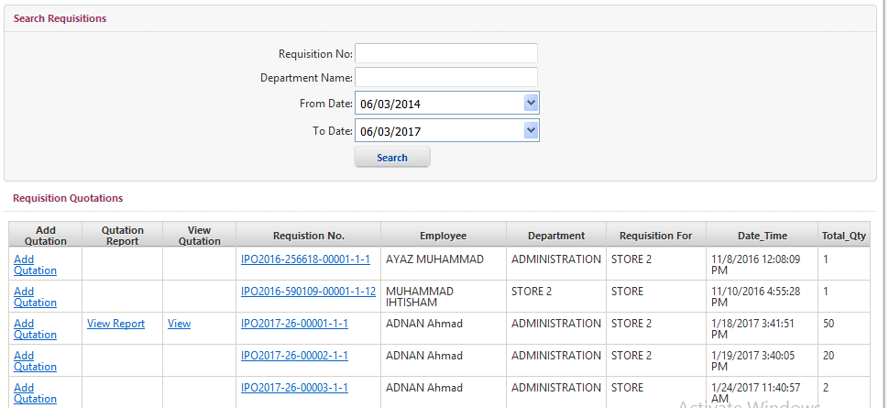

Receive Inventory By Request:
- Click on Inventory Module from menu bar.
- Select Receive Inventory By Request from drop down list of Inventory Module.
- Screen will appear as mention below screen.
- To view report of receive inventory by request click on View Report.
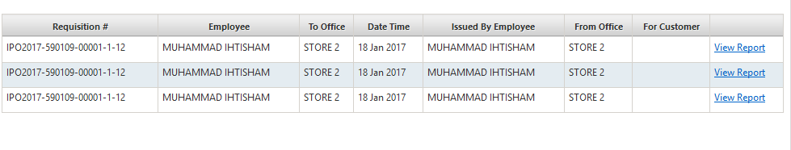

Party Ledger:
- Click on Inventory Module from menu bar.
- Select Party Ledger from drop down list of Inventory Module.
- Screen will appear as mention below screen.
- Select Company Branch from drop down list of Company Branch select box.
- Select Party from drop down list of Party select box.
- Select From Date from drop down From Date dialog box.
- Select To Date from drop down To Date dialog box.
- Click in View Report Button.
- Party Ledger detail will display.

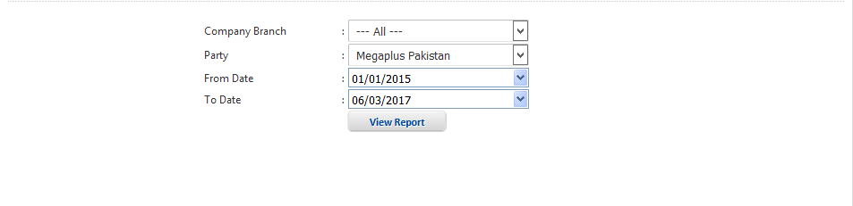

Party Payable and Receivable:
- Click on Inventory Module from menu bar.
- Select Party Payable and Receivable from drop down list of Inventory Module.
- Screen will appear as mention below screen.
- Select Company from drop down list of Company select box.
- Select Branch from drop down list of Branch select box.
- Select From Date from drop down From Date dialog box.
- Select To Date from drop down To Date dialog box.
- Enter Party Name in text box.
- Click in Search Button.
- Party Payable and Receivable report will display at the bottom of screen.

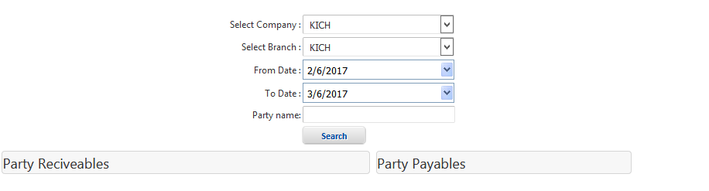

Min Approval Authority For Demand Requisition:
- Click on Inventory Module from menu bar.
- Select Min Approve Authority from drop down list of Inventory Module.
- Screen will appear as mention below screen.
- Select Sub-Department from drop down list of Sub-Department select box.
- Select Level from down list of level select box.
- Click on save button.
- Detail will save and display at the bottom of screen.

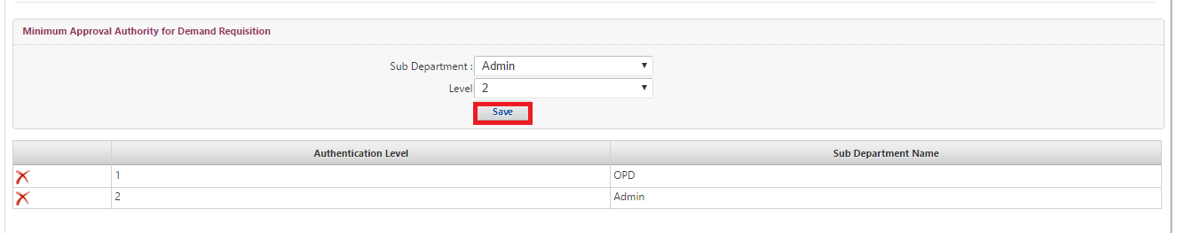

Approval Authorities For Demand Requisition:
- Click on Inventory Module from menu bar.
- Select Approval Authorities from drop down list of Inventory Module.
- Screen will appear as mention below screen.
- Select Sub-Department from drop down list of Sub-Department select box.
- Select Employee (Authority) from drop down list of Employee (Authority) select box..
- Select Level from down list of level select box.
- Click on save button.
- Approval Authorities Detail will save and display at the bottom of screen.

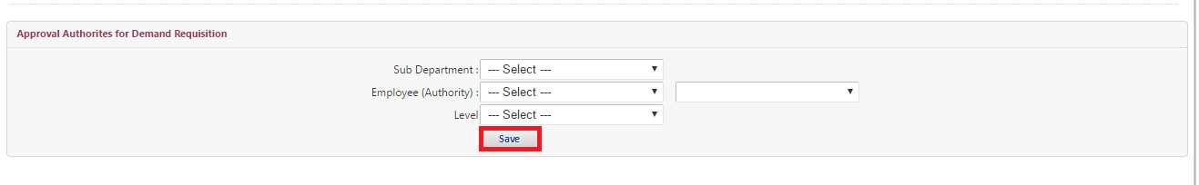

Demand Requisition:
- Click on Inventory Module from menu bar.
- Select Demand Requisition from drop down list of Inventory Module.
- Screen will appear as mention below screen.
- Select From Office from drop down list of From Office select box.
- Select Send TO Office from drop down list of Send To Office select box.
- Select Send To Store from drop down list of Send To Store select box.
- Enter Requisition Description in Requisition Description text box.
- Search Item by enter Item Name in Item Name text box.
- Select Manufacturer from down list of manufacturer select box.
- Click on Search button.
- To roll back click on Roll back button.
- To save information click on Save & Submit button.

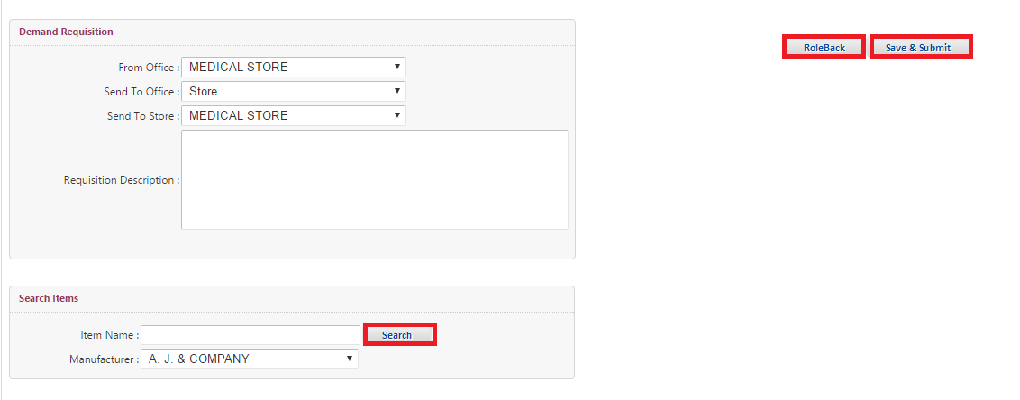

Search Demand Requisitions:
- Click on Inventory Module from menu bar.
- Select Search Demands Requisition from drop down list of Inventory Module.
- Screen will appear as mention below screen.
- Enter Requisition # in requisition text box.
- Select Employee from drop down list of Employee select box.
- Select From Date from drop down From Date dialog box.
- Select Department from down list of department select box.
- Click on Pending work flow check box.
- Select To Date from drop down To Date dialog box.
- Click on View Requisition.
- Demand Requisition detail will show.

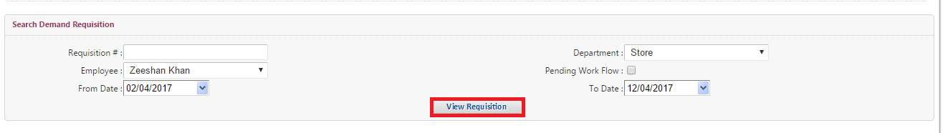

My Pending Approvals Requests:
- Click on Inventory Module from menu bar.
- Select My Pending Approvals from drop down list of Inventory Module.
- Screen will appear as mention below screen.
- For Approval Request click on Approve & Forward.



POS:
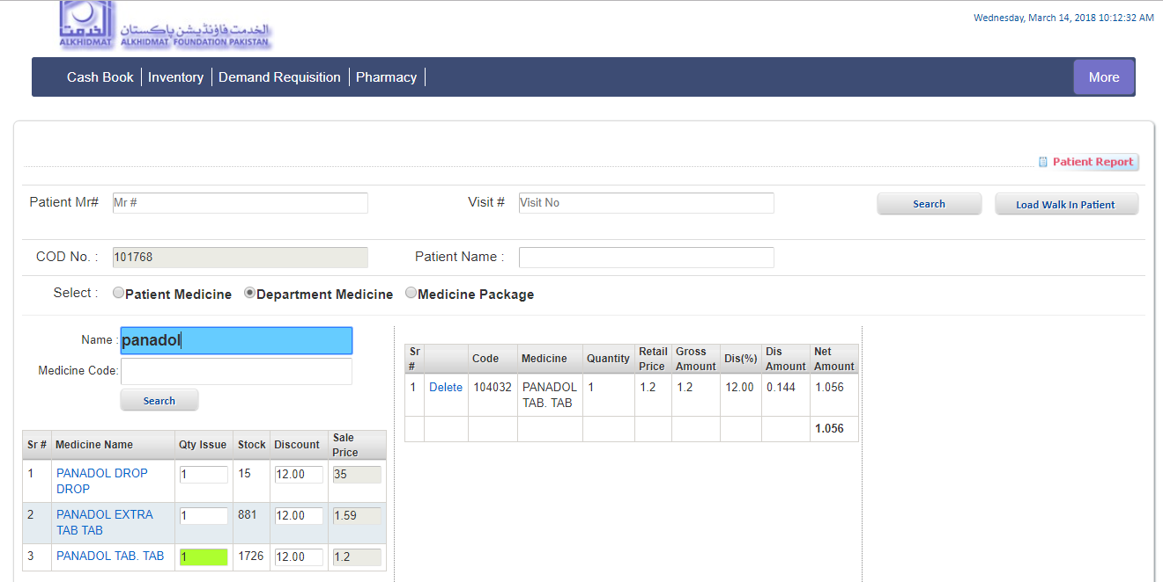
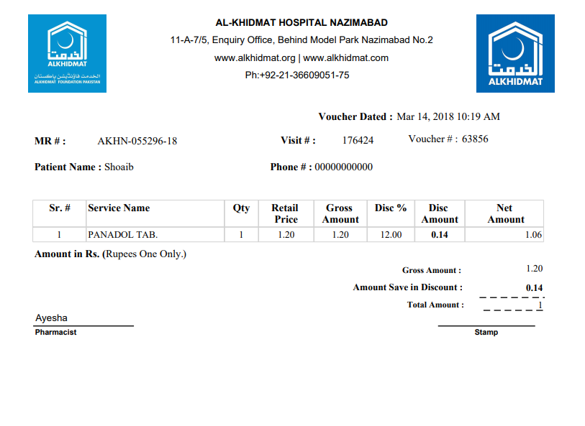

Counter Close:

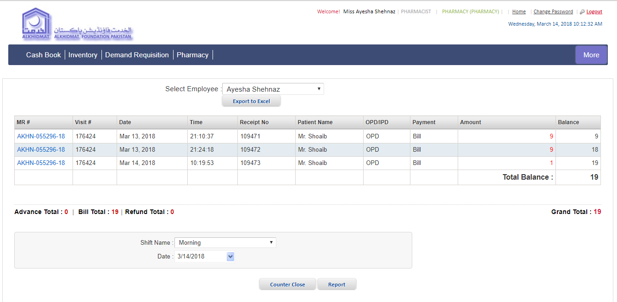

Counter Close:
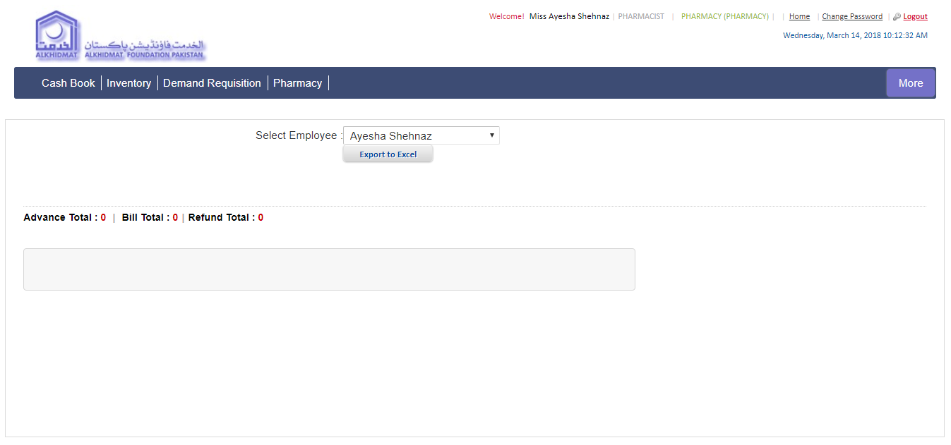

Item Wise Stock Report:

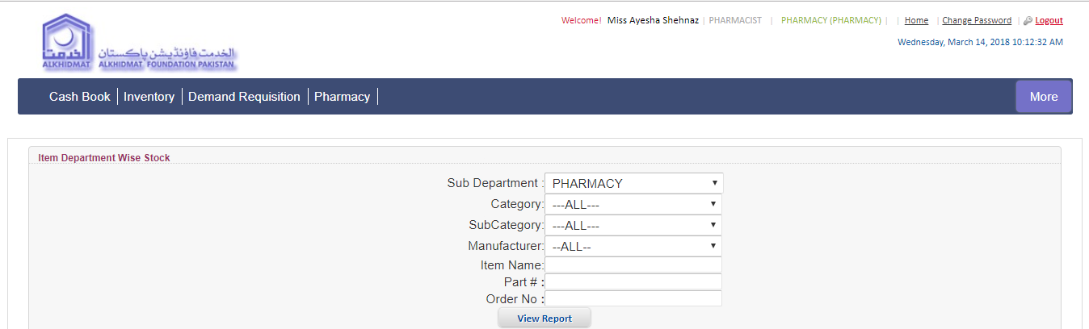
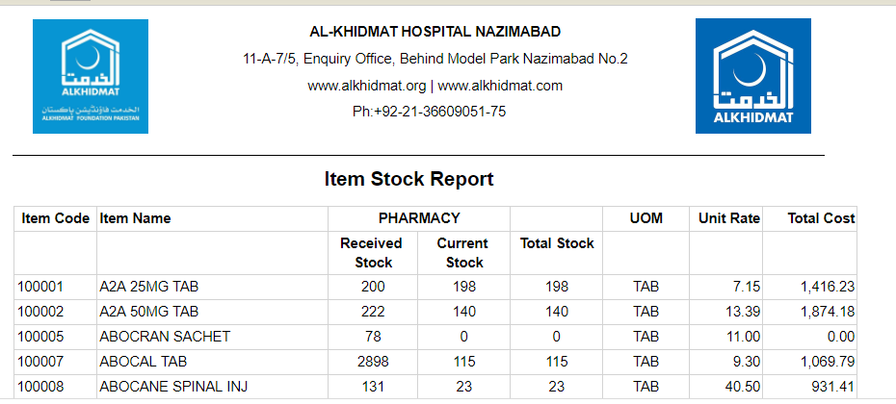

Item Wise consumption:

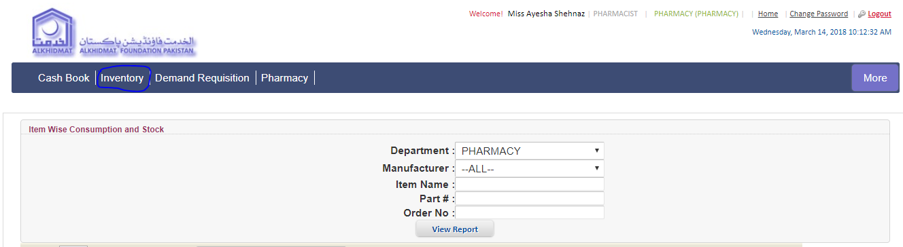
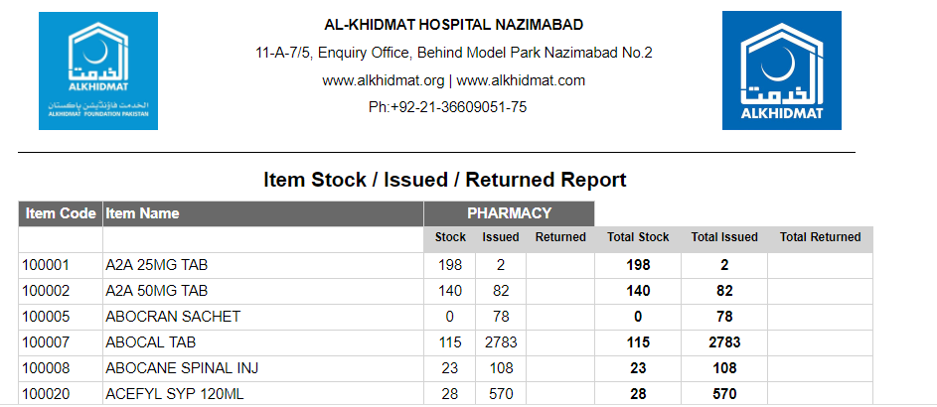

View All Department Stock:

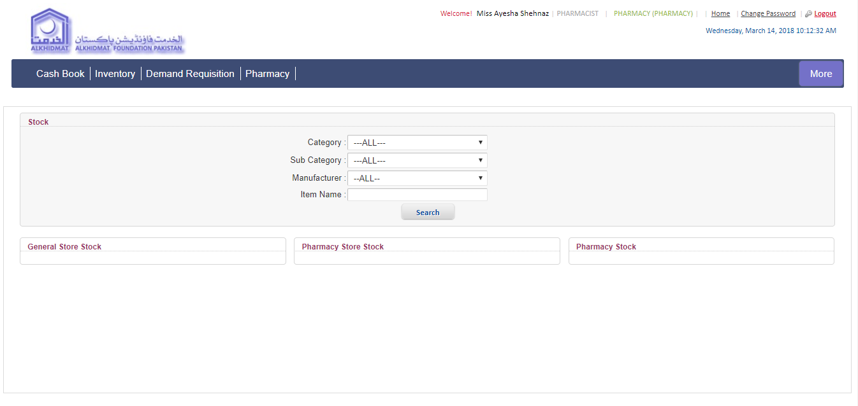

Stock In/Out Report:

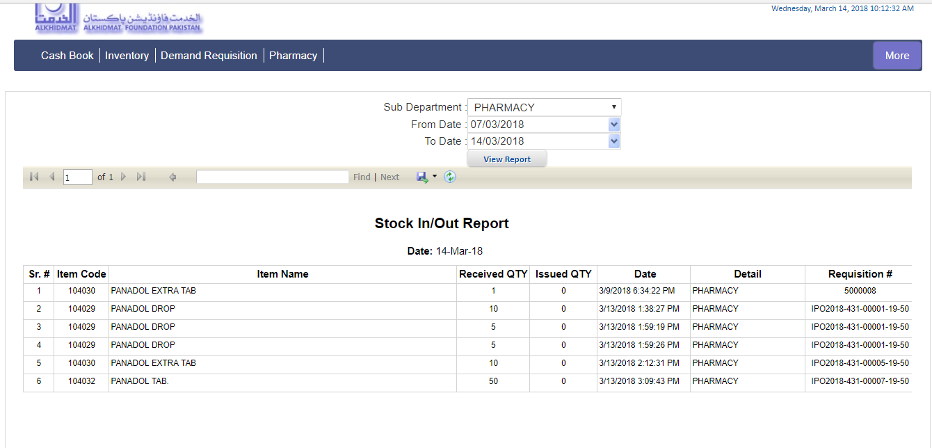

Stock in Transit:

